2016 Benson Clapton Guernsey Auction Article

Clapton, Benson guitars go on the block
February 22, 2016 10:23 PM

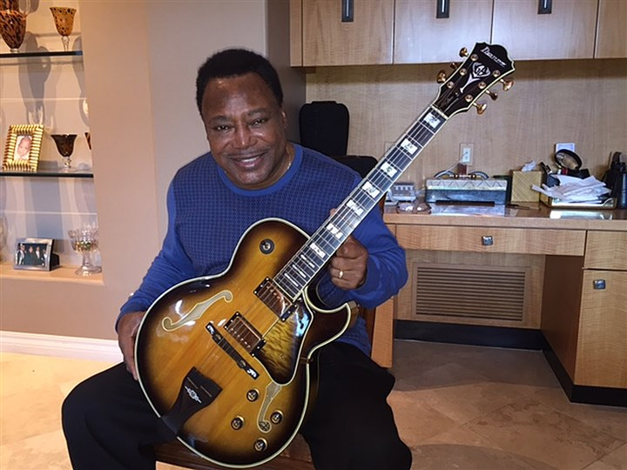
A guitar George Benson consigned to auction.
By Marylynne Pitz / Pittsburgh Post-Gazette
When Pittsburgh native George Benson performs his hit song “On Broadway,” he prefers to play a guitar custom-made for him by Ibanez, a company headquartered in Japan.
Eric Clapton loved a guitar he called “Blackie.” When it wore out, Fender made the Eric Clapton Stratocaster, producing it in 1988 in Ferrari red, 7-Up green and charcoal gray.
These instruments, suffused with a celebrity glow, are among more than 225 guitars offered for sale Saturday by Guernsey’s at Bohemian National Hall, 321 East 73rd St. in New York City. Buyers can attend in person or bid on the Internet (guernseys.com) or by telephone.
A 1982 guitar made by Charvel for Eddie van Halen is on the block, too, along with early acoustic guitars produced by C.F. Martin & Co., based in Nazareth, Pa.
Arlan Ettinger, who started Guernsey’s, met Mr. Benson two years ago when he was in Arizona, meeting with the family of the late Waylon Jennings.
“George is a very personable, lovely man who, in my opinion, has not let great success go to his head,” Mr. Ettinger said in a telephone interview.
While the two men talked in Mr. Benson’s home, the musician often sat with a guitar on his lap, “noodling along as we were talking. It’s almost like breathing.” Mr. Ettinger said.
For Saturday’s auction, Mr. Benson, 72, consigned 18 guitars he had in storage.
“Why keep all these instruments in a storage room when ... fans of his will have a chance to own and play something that he did?” Mr. Ettinger said.
In “Benson: The Autobiography,” the entertainer recalls that his stepfather, Tom Collier, made his first electric guitar, modeling it after one the young George saw in a Pittsburgh shop window but could not afford. Mr. Benson began playing guitar at age 9.
The Ibanez guitar, whose pre-sale estimate is $2,000-$3,000, is made of Sitka spruce and has a lacquer finish that has turned a beautiful amber. The fingerboard contains the original frets, and there is high-quality gold hardware. Mr. Clapton’s Stratocaster in bright green is expected to fetch $2,000-$3,500 at auction.
- Rebecca Apodoca, a certified appraiser, has valued instruments for Christie’s and runs A & D Music in Laguna Beach, Calif. She said vintage guitars draw musicians and investors, comparing the latter to ticket scalpers. “They own the tickets, but they don’t hear the music. They don’t go to the concert. They’re just looking at the money.”
Hanging a guitar on a wall like an animal head does not benefit the instrument, she said. “Because they’re unplayed, that affects their tone. Guitars need the vibration to reach their maximum potential.”
As an independent appraiser, Ms. Apodaca declined to discuss values for specific instruments.
“Many makes and models will fluctuate due to the popularity of professional musicians. You hear the tonality that person is getting when they recorded or played live. Now a guitar player wants to sound like that. It’s investing in the best tool,” she said.
“Professional musicians and actors are the royalty in America, so their instruments are desired,” Ms. Apodoca said. “If you have the original, that’s much more valuable.”
To determine an instrument’s value, she examines what materials were used, the originality in the design, the condition of the instrument and comparable sales. Woods such as spruce, cedar, rosewood, mahogany and ebony either reflect sound better or are especially durable.
Also available at the auction are a rare 1971 Rickenbacker Lightshow guitar and a 1970 Transonic amplifier. Since its founding, California-based Rickenbacker Co. has made innovative instruments.
“Rickenbackers are always desired. They haven’t mass-produced them in Indonesia and China. They are made here in the U.S.A. in Southern California,” Ms. Apodaca said.
Marylynne Pitz: 412-263-1648 or mpitz@post-gazette.com.
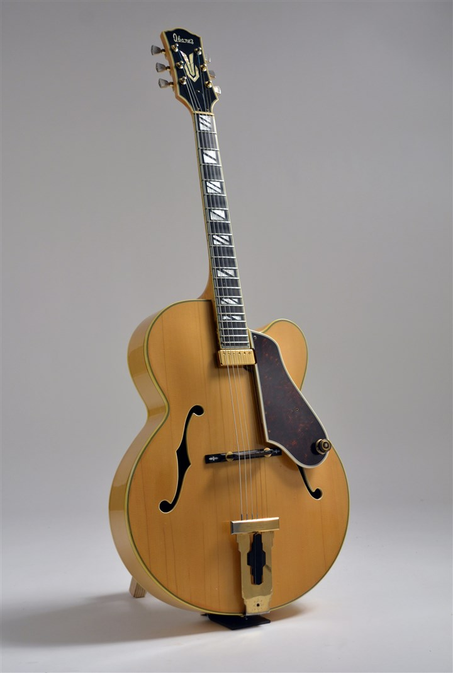
Lot No. 435 from the George Benson collection. Copy of a Johnny Smith guitar made by Ibanez for George Benson, who consigned it for the Feb. 27 auction. Estimated Price: $2,000 - $3,000.
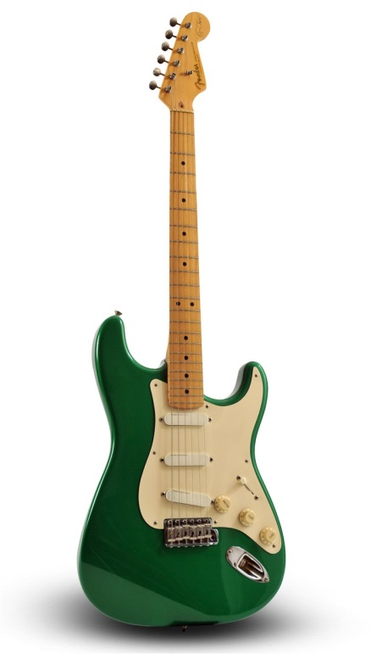
This custom-made guitar in "7-Up Green" is called the "Eric Clapton Stratocaster" and was made of maple at the Fender Custom Shop in 1985. Clapton signed it in black ink.
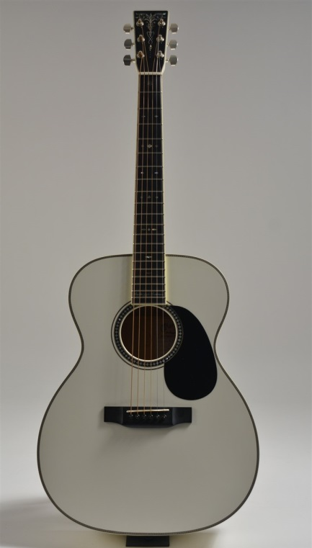
This 2004 Martin Bellezza Bianca prototype was the third of four guitars built for Eric Clapton by Martin. It was introduced as a limited edition guitar in 2006.

